Kisa Phone

Type of device: Mobile
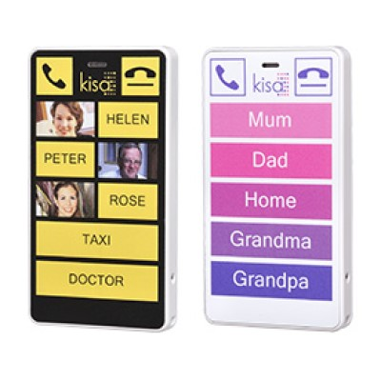

Actual Display Size : This phone does not have a screen
Button Type : Physical Keypad
Network Capability : 3G
Year of Release : 2014
Average Price : $194 as of 27/11/2019

Accessibility Features:

Cognitive
- Additional Instructions
- GPS
- Photo Telephone List
Simplify Display

Hearing Impairment and Deaf
Visual Alerts - Incoming Calls

Vision
- High Contrast Mode
Power Cue

Physical
- Flat Back for Table Top Operation
- Headset - plug connected
- Lanyard Option
Speaker-phone option

How and where to get it from?
You can buy this phone from Kisa Phone, and other retailers.

More information is available on:
Kisa Phone Web Page
Kisa Phone Brochure (PDF Download)

